Indian Institute of Technology, Kharagpur
Centre for Educational Technology

Mid Semester Examination 2013

Subject: INTRODUCTION TO DIGITAL SPEECH PROCESSING Code: ET60007

Time: 2:00 Hours PART-A:-10*2=20
PART-B:-5*6=30
Full Marks =50
Answer all the questions of PART-A and PART-B
(Please enclose the Annexure-1 along with the answer script)
PART-A
- Table 1 shows an F₁ and F₂ of the vowels of a language plot the vowels in F₁ and F₂ plane and mark the axis intern of tongue height tongue position.
Table-1
Vowels | F₁ [Hz] | F₂[Hz]
/u/ | 325 | 1035
/o/ | 378 | 1025
/ɔ/ | 543 | 1019
/a/ | 866 | 1530
/æ/ | 591 | 1846
/e/ | 383 | 1978
/i/ | 309 | 2131

- In case of sound perception why we need two ears?

- Acoustic intensity of an audio system is 5W/m². Represent it in dB and find out the Loudness (L) in Sones.

- Write the phonetic transcription for the following words. How many syllables are present in each of the above word?
- “Production” (b) “Perception”

- Write the place and manner of articulation of the following phonemes?
/g^{h}/, /u/, /m/, /ɖ/

- First formant frequency of a steady state vowel is F₁=250Hz. Consider that the vowel is produced using a single lossless acoustic tube. What will be the length of the vocal tract? How long is the impulse response of the tube? Where the speed of sound c=350m/s.

- Two source of speech signal producing a vowel /o/. The formant frequencies of the sources are differing by 3-4%. If a human being perceives the two sounds as same sound explains why this happen?

- 2 sec. speech segment is encoded using LPC coefficient and the LPC coefficient are extracted for each frame (frame length(L)= 5 pitch period) with a frame rate 100 frame/s. Determine the required order of the LPC analysis and how many frame’s LPC coefficient can be extract from the above speech signal. where the F₀ of the speech segment is 250 Hz and sampling frequency F_{s}=16 kHz

- Define critical band for human auditory system. What will be centre frequency of the 7th critical band in bark scale? Where the bark is as define below.

- Which of the following pair of tones is perceived as louder tone?
(a) 25dB level at 200Hz and 25 db at 600 Hz (b) 5dB level at 7 KHz and 5dB level at 2 KHz
PART-B
- (a) An analog signal x_{a}(t)=6sin(320πt)+4cos(820πt) is sampled at 600 Hz. Dertermine the F₀ of the signal. How many sampled will be present in one fundamenal period?
(b) A discrete signal x[n]=6.35 cos(πn/5) is quantized with aresolution Δ=0.01. how many bits are required in A/D conversion?
(c) If the above degitized signal is passthrough an digital to analog converter, derive the expresion of the reconstracted signal.

- Linear prediction analysis is used to obtain a 6-order all-pole model for a segment of voiced speech that was sampled at a rate of F_{S} = 10000 Hz. Figure -1 shows the LPC spectrum of the above extracted LPC coefficient. Determine the root magnitude and root angle of the pole corresponding to first three formant. F₁=288Hz , F₂=719Hz, F₃,=2294Hz BW₁=92 Hz, BW₂=65Hz, BW₃=50Hz
F1

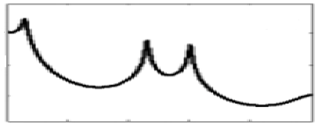
BW1
BW2
BW3
Frequency
F3
F2

Figure-1
- Bilabial unvoiced fricative sound is produce by constrictions in vocal tract at lips. Consider the vocal tract is model using a lossless uniform tube of length l. The output sound pressure at lips to produce the above fricative sound is P_{L}(Ω)e^{jΩt}. Using the wave equation derive the transfer function H(Ω) (where H(Ω)=U_{L}(Ω)/P_{L}(Ω))

Using the radiation load R_{L}=jΩL_{r}R_{r}/R_{r}+jΩL_{r} derive the expression of sound pressure at front of lips.

- (a) Figure-2 (a) and (b) in annexure-1 represents waveform and spectrogram of a VCV speech segment where C represent consonant and V represent Vowel. Mark the occlusion period, burst and VOT part? Write the manner of articulation of the consonant represented by the figure-2.
(b) Figure-3 in annexure-1 represent wideband spectrograms of a speech segment mark the following region your knowledge of acoustic phonetics i) voiced segment ii) unvoiced segment iii) any one consonant to vowel transition segment

- (a) Draw the LPC decoder and encoder block diagram

(b) A signal is sampled at 16 KHz, 16 bit, encoded with 18th order LPC. Each of the LPC coefficients is encoded with 2 byte, Gain in 2 byte. Voiced unvoiced F₀ information is encoded using 1 byte. What is the compression ratio if frame rate is 100 frame /sec?

Annexure-1

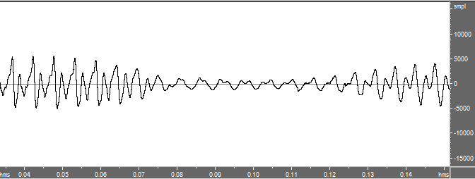
(a)
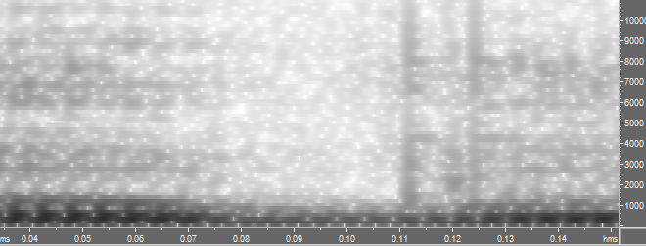
(b)
Figure-2

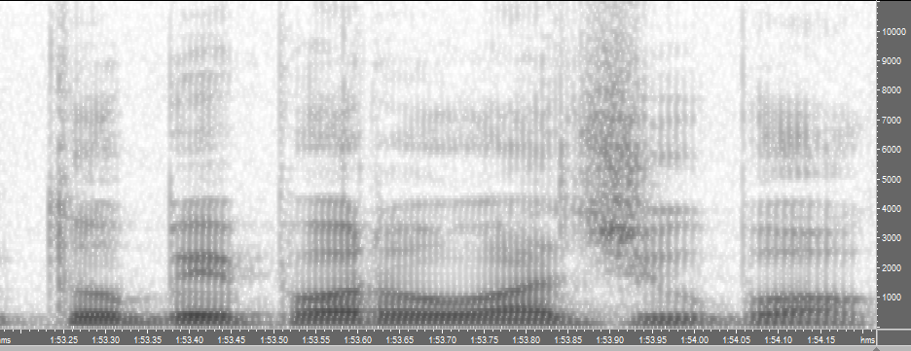
Figure-3

